PLAYGROUND UPDATE

Randles Lane – Wetley Rocks

Tyres – KH has been to assess them, they are cemented in so intention is to remove them, cut off tyres dig out the concrete, if necessary, infill and grass over – this will be done Wednesday 4th – New ones to be installed in the future.

Foliage – it appears to have been cut back, by whom? It is to be completed to satisfy the moderate risk identified on the playground report. Cllr Shaw has confirmed with the chair that he does not know who has done this, KH will complete on 4th weather permitting.

Spring Dog – rocker equipment – replace seat and treat rust and repaint the spring – Steve Billings

Toll Bar – Southlowe

Swings need an uplift – surfacing trip hazard, shackles chains need replacing – wear in excess of 40%
Options – Soveriegn Play – would require another survey by themselves, another repair company (Online Playgrounds) simply to fix, in house – but does this option for repair ensure compliance with BS

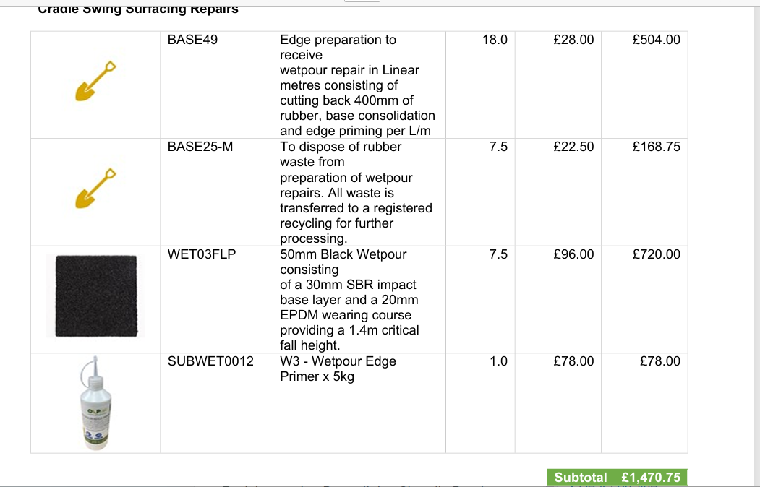

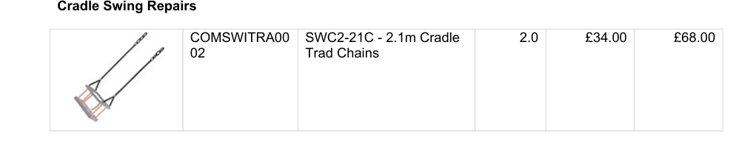
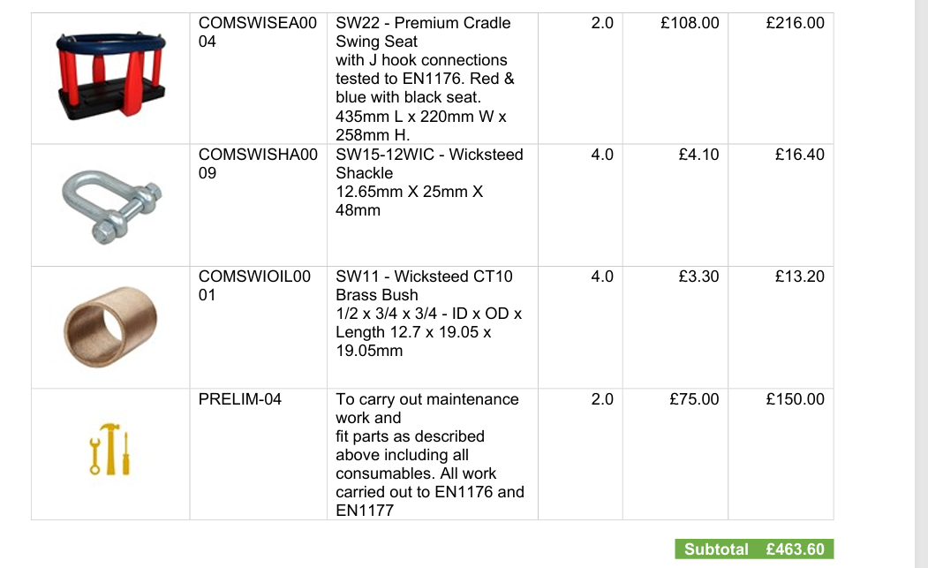
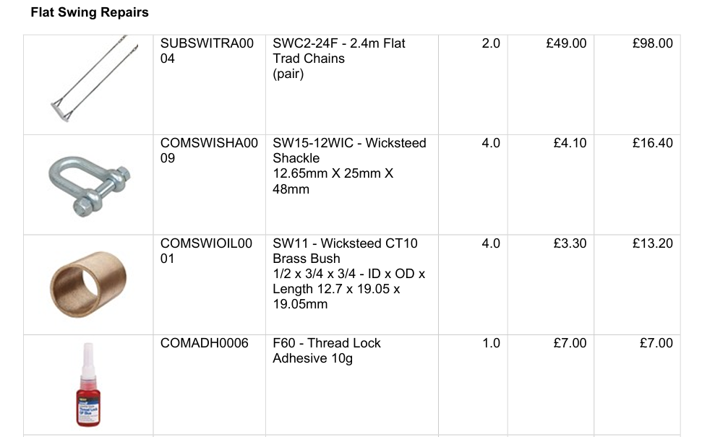
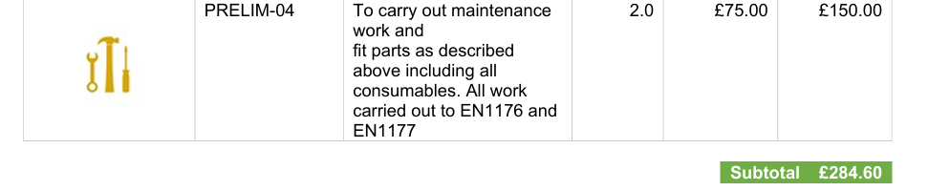

£2300 for Toll Bar repairs using Online Playgrounds

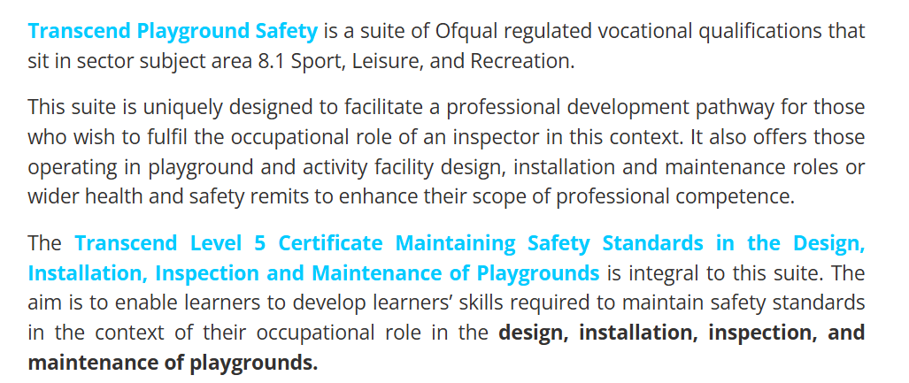

Option to train someone – ask if a member of the community has this qualification.

Grange Road
Zip wire –
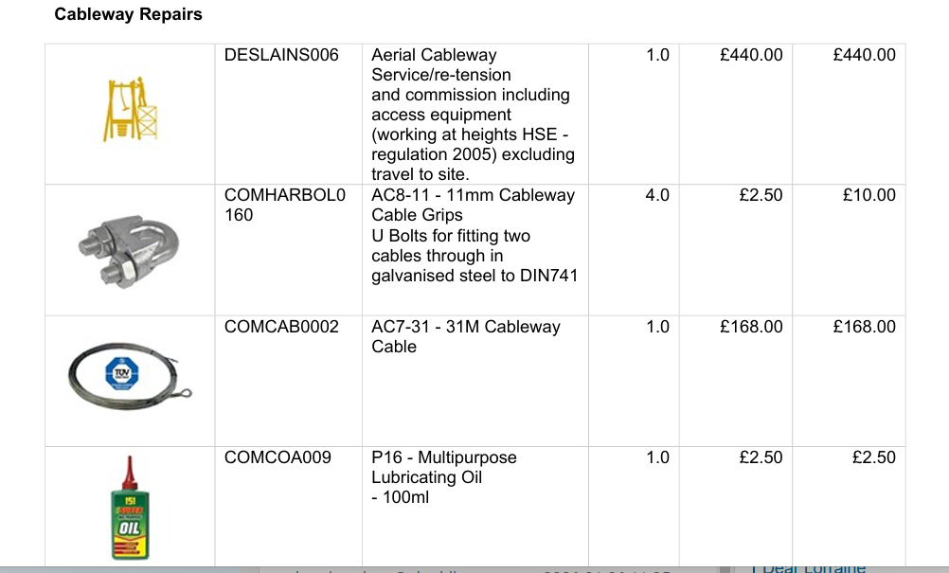
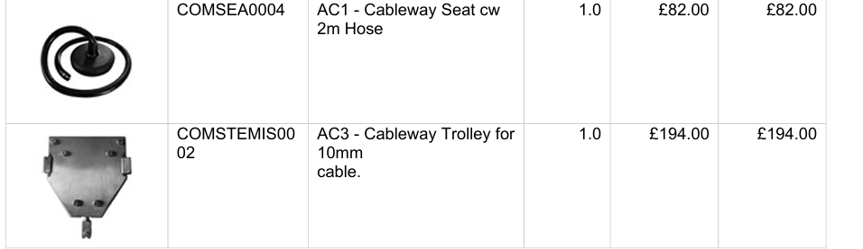
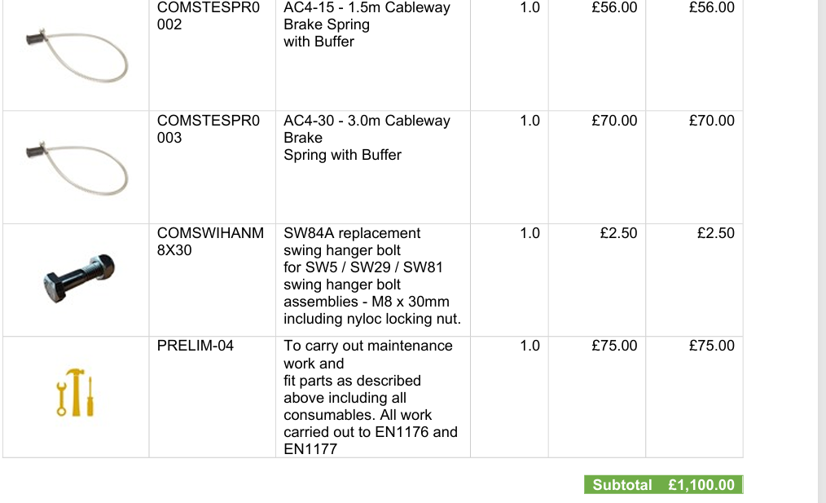
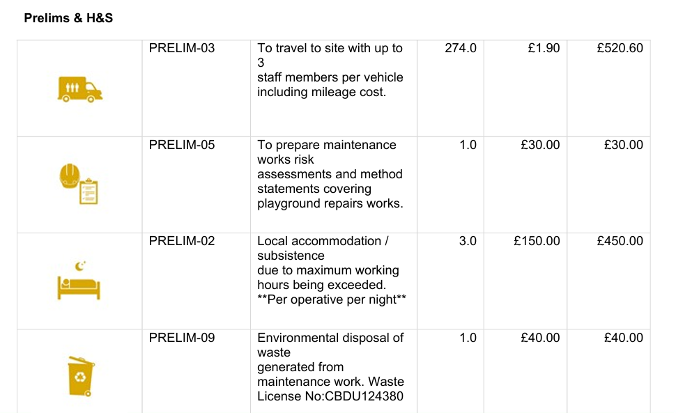
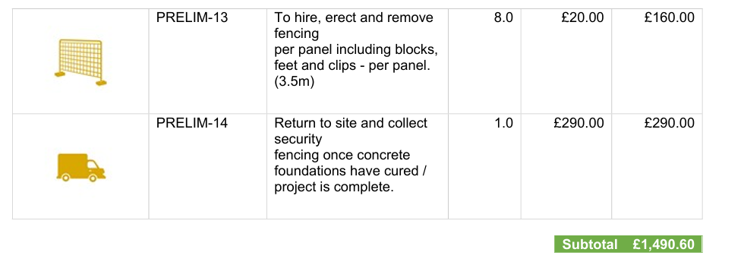

Above additional costs include sleeping over if they were completing all works on the playing field, this element would need to be requoted

Childrens slide - - in house an option subject to concerns re BS as above

Large swings – wood rotting needs repair, worn chains, shackles, seats, bushes worn or missing, seat connectors worn
£385 and £432 required for the equipment – surfacing in addition –

Handyman Yes is this the way forward – buy the parts Steve to fix
Can a handyman replace new parts on a playground facility
Yes, a handyman can replace new parts on a playground facility. They can handle minor repairs and replacements, such as tightening loose bolts or replacing worn swing seats. However, for significant structural damage or complex issues, professional repair services are recommended to ensure proper fixes are made. It's essential to document all repairs and maintain a record of the work done to comply with safety regulations and standards. Regular maintenance and inspections are crucial to prevent future issues and ensure the safety and functionality of the playground equipment.

Main area of concern being the wetpour areas, trip hazards

This needs to be considered separately

PROPOSAL
PC to purchase parts
Steve Billings to fit
In house Cllr to train in order to complete standards checking – does anyone have this qualification already?

