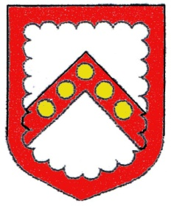
Cheddleton Parish Council

Clerk: Mrs Melanie Matthews

Email: clerk@cheddleton-pc.gov.uk Phone: 01538 711 399

Meeting of the HR Committee

Dear Councillors,

Councillors are summoned to a HR Committee Meeting of Cheddleton Parish Council which will be held at Cheddleton Community Centre, Hollow Lane, Cheddleton on Wednesday 15th April 2026 at 7pm.

The press and public are NOT invited to attend the meeting due to the nature of the agenda items.

Yours sincerely,
Mrs. M Matthews
Parish Clerk and RFO

AGENDA

Exclusion of the Public
The public to be excluded because of the likely disclosure of exempt information as defined in Public Bodies (Admissions to Meetings) Act 1960 Section 2.

- Apologies
To receive any apologies (through the Clerk in accordance with Standing Orders).
- Declaration of personal & prejudicial interest or requests
For dispensation on any item on the agenda. Members should notify Monitoring officer within 28 days if not already declared.
- Minutes of the Meetings - Attached
Proposal to confirm and accept the minutes of HR Committee on 13th August 2025 as true and accurate record
- IR35
Proposal to confirm IR35 stance

- Clerk
Proposal to allow the Clerk to commence work at 11:00am on Wednesdays following Tuesday evening meetings.
Proposal to set up a standing order for the Clerk’s basic salary, with expenses and mileage reimbursed separately.

- Contractors
Proposal to confirm contractor arrangements

- Correspondence
Proposal for council to confirm next steps

END OF MEETING

